**MACHINE 2 : FUNBOX**

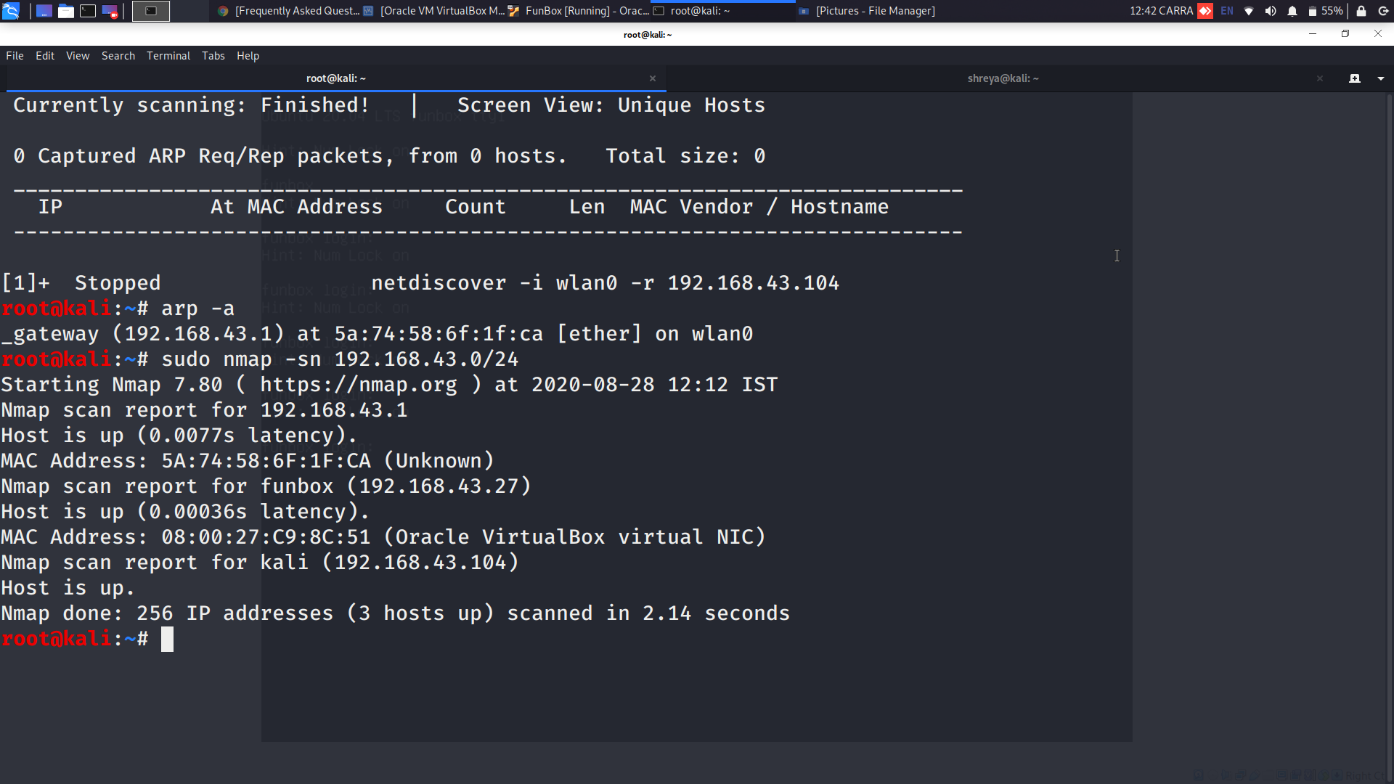

**-sn: Ping Scan - disable port scan**

**Now we will do nmap probing on target ip i.e, 192.168.43.27**

**Below are the results :**

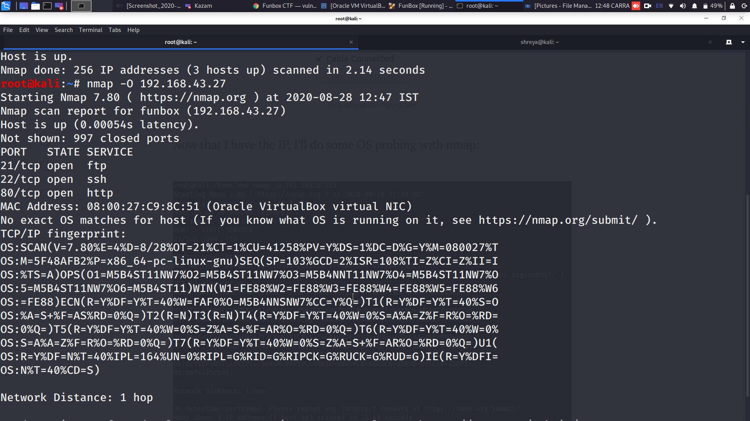

**-O : Determines the type of OS and gives info about it. ftp command is useful when you work on a server without GUI and you want to transfer files over FTP to or from a remote server.**

**If I browse to the ip, I get redirected to funbox.fritz.box:**



**Lets fix it by adding an entry on my hosts file:**

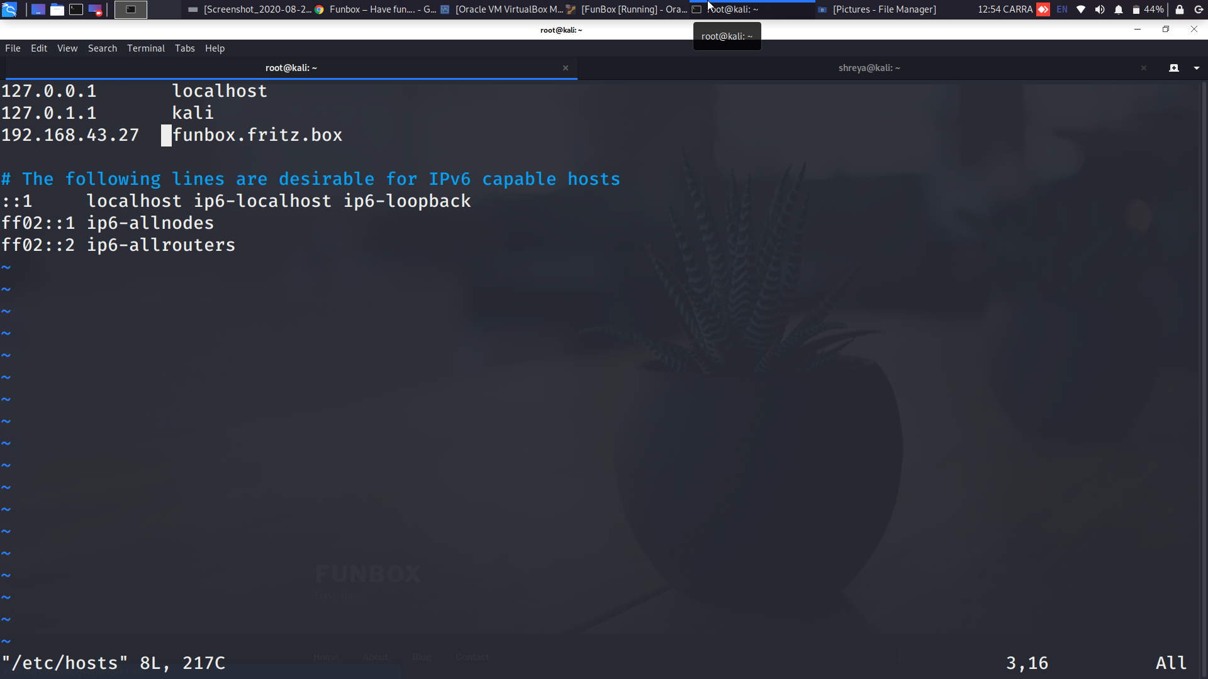

**And the site loads correctly now:**

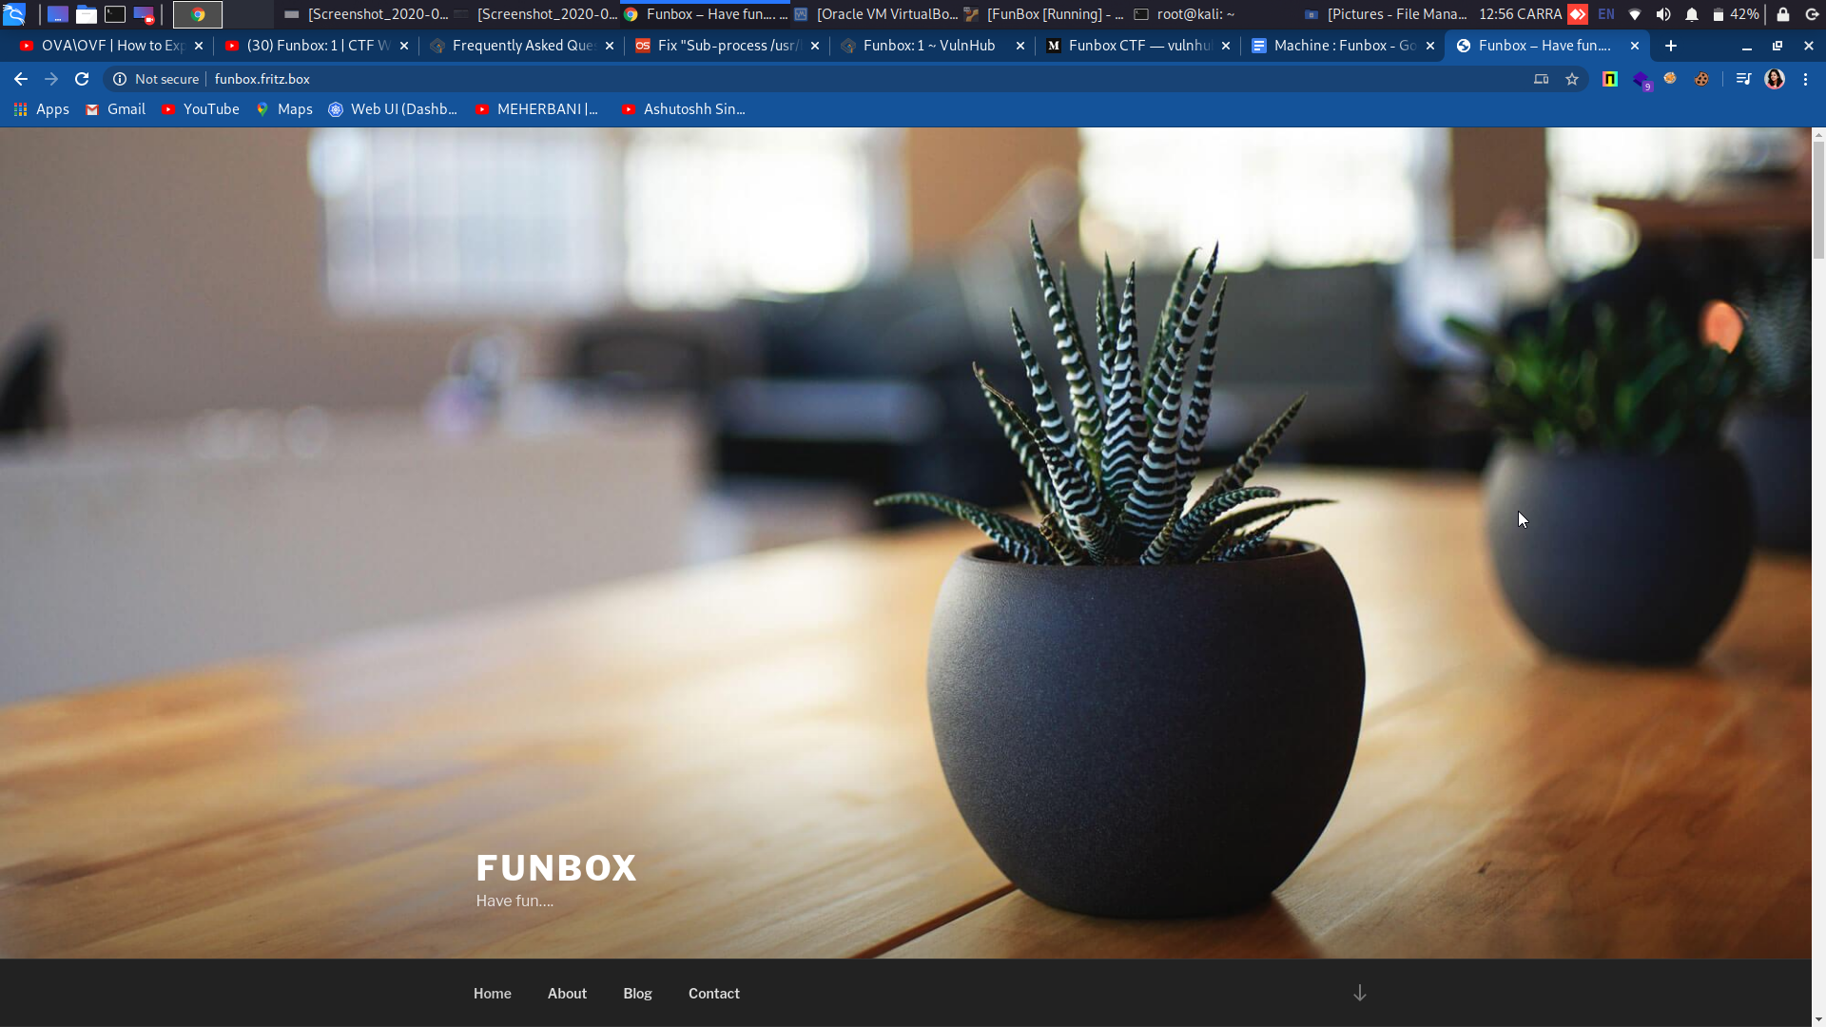

**Now as we scroll down we can see that its using Wordpress :**

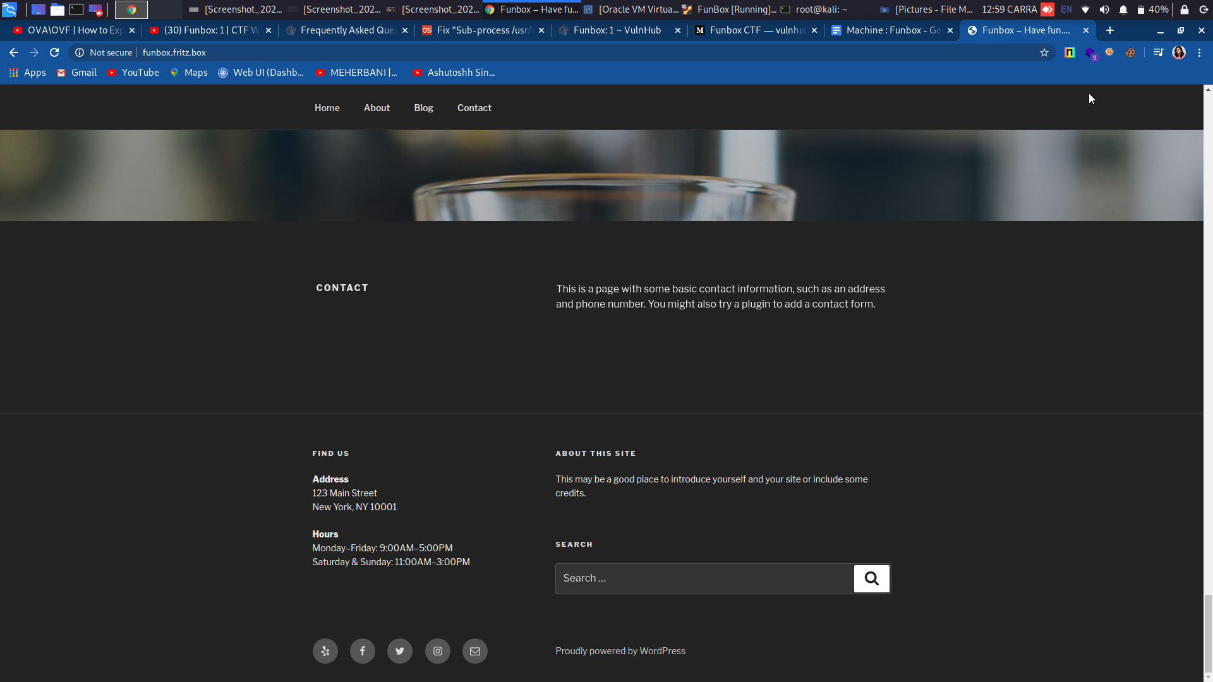

**Using wpscan let’s do some basic enumeration (plugins/users) to find something obvious:**

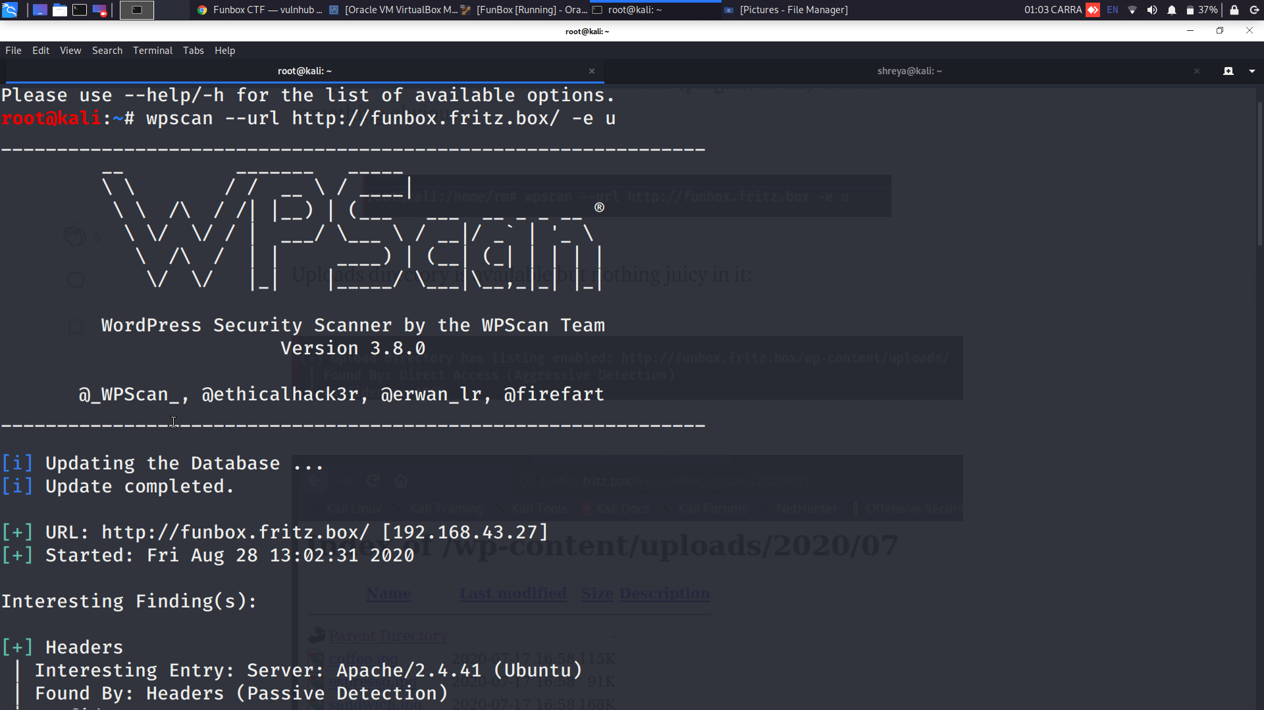

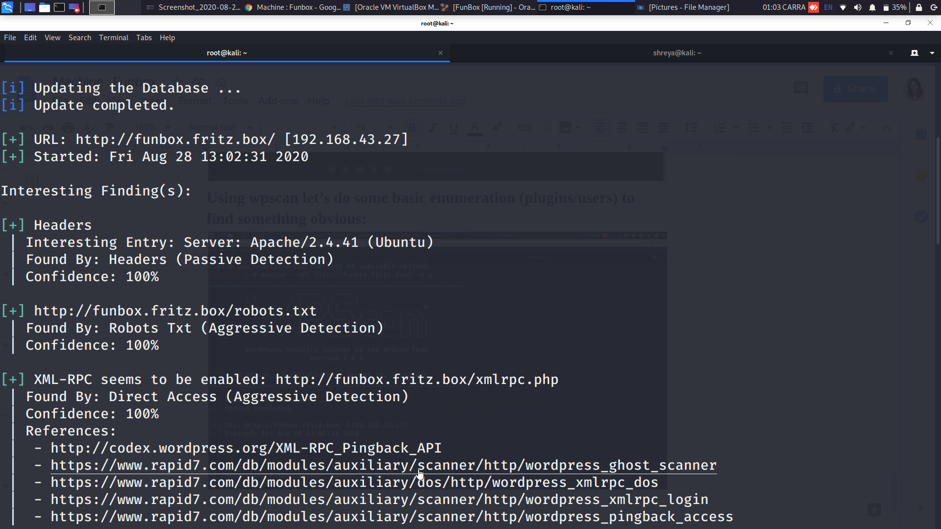

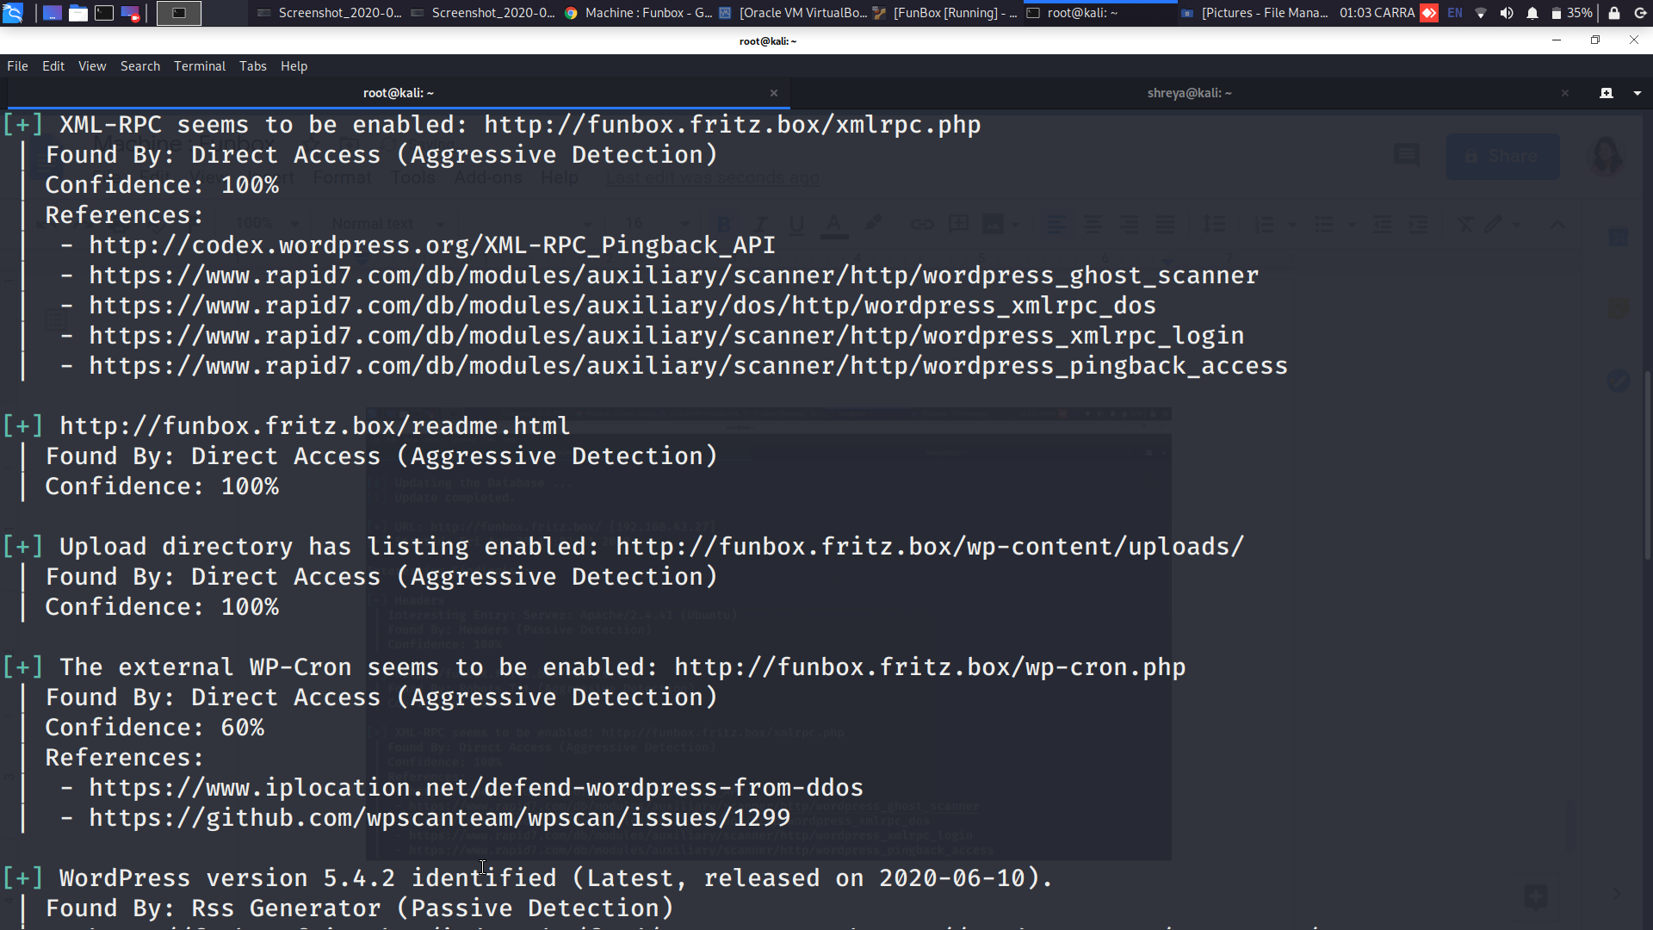

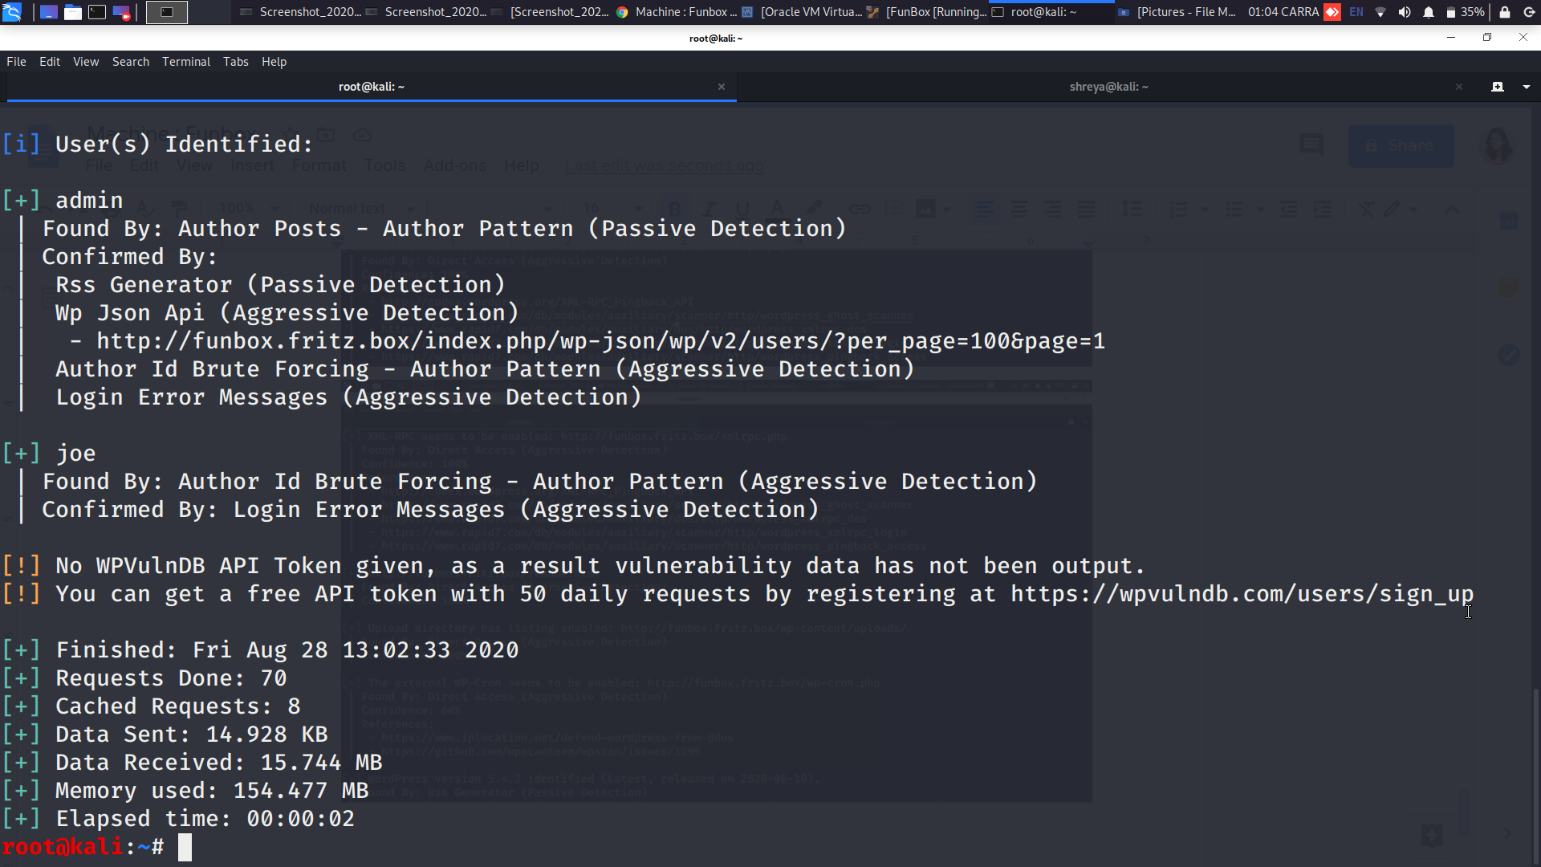

**Uploads directory is available but nothing juicy in it:**

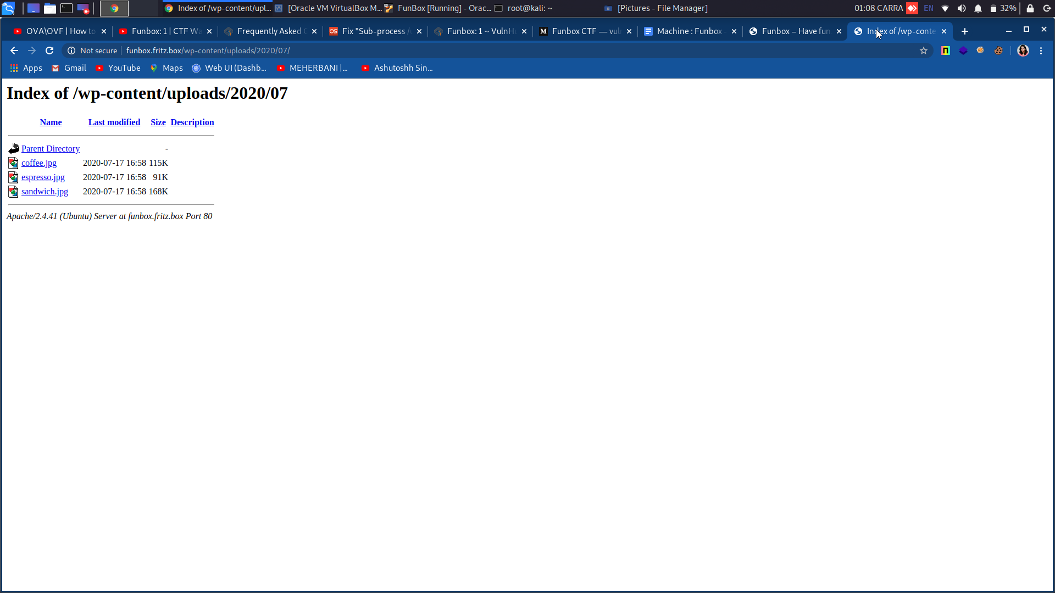

**We have two users available, admin and Joe. Usually admins have higher security so let’s go for Joe. Using WPScan let’s run Joe through a wordlist (rockyou.txt) and see if we find something:**

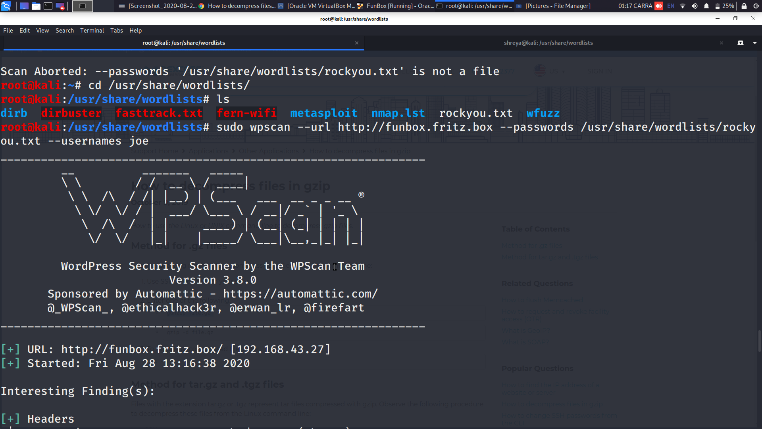

**Here, we found the login credentials of joe:**

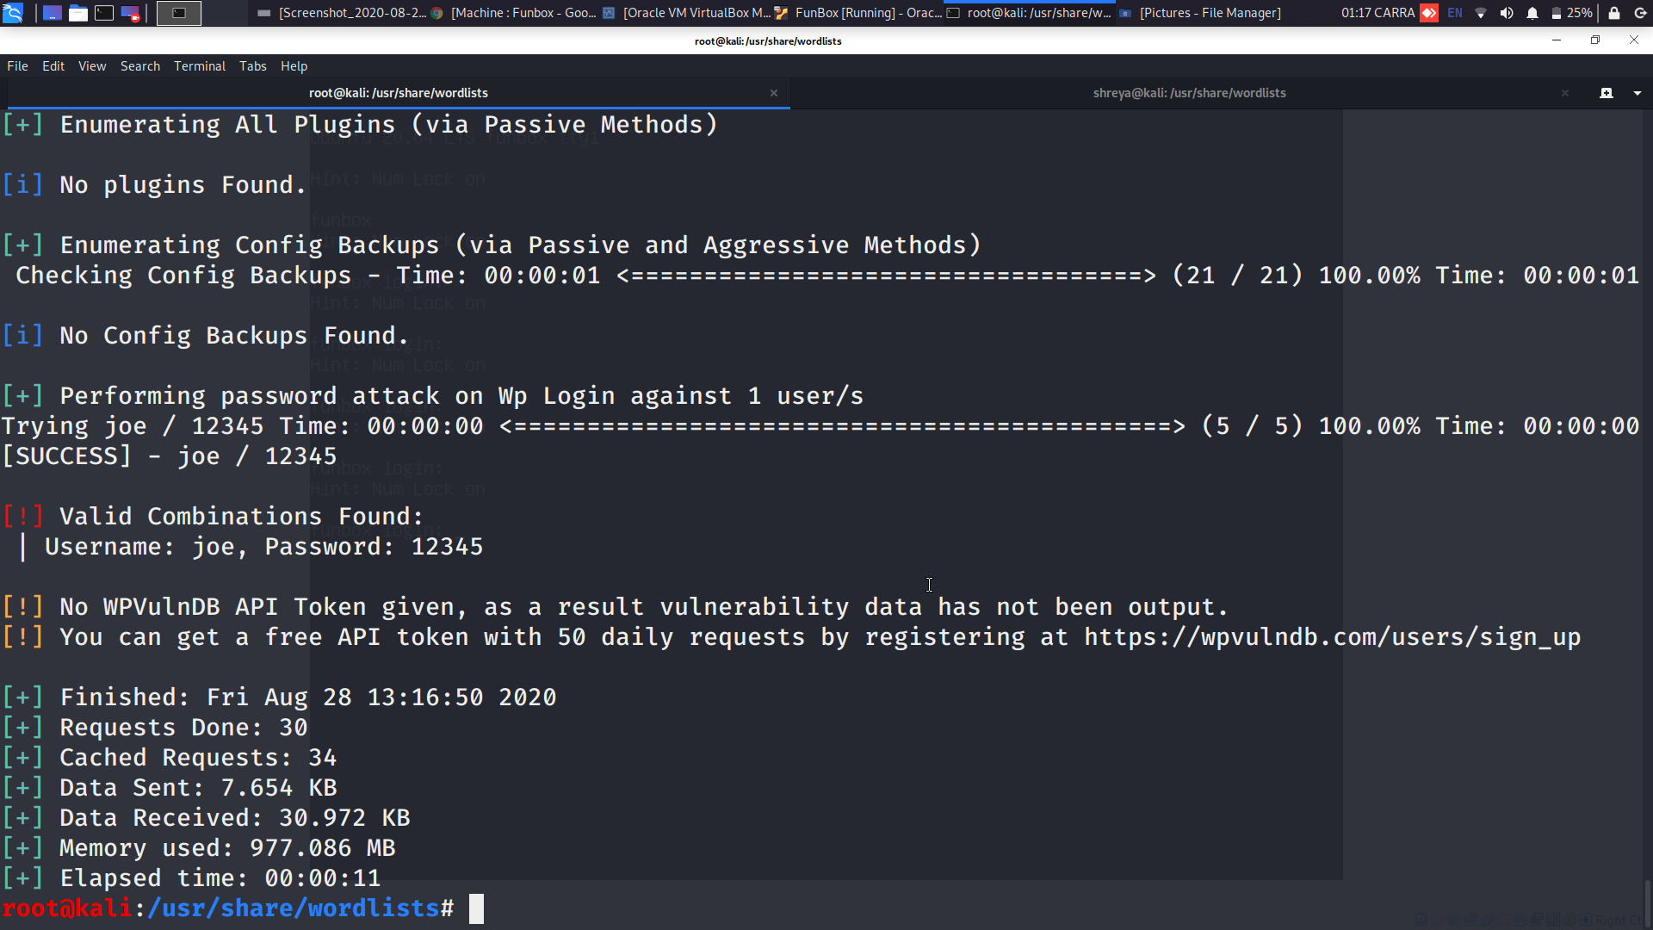

**Now lets see by logging in:**

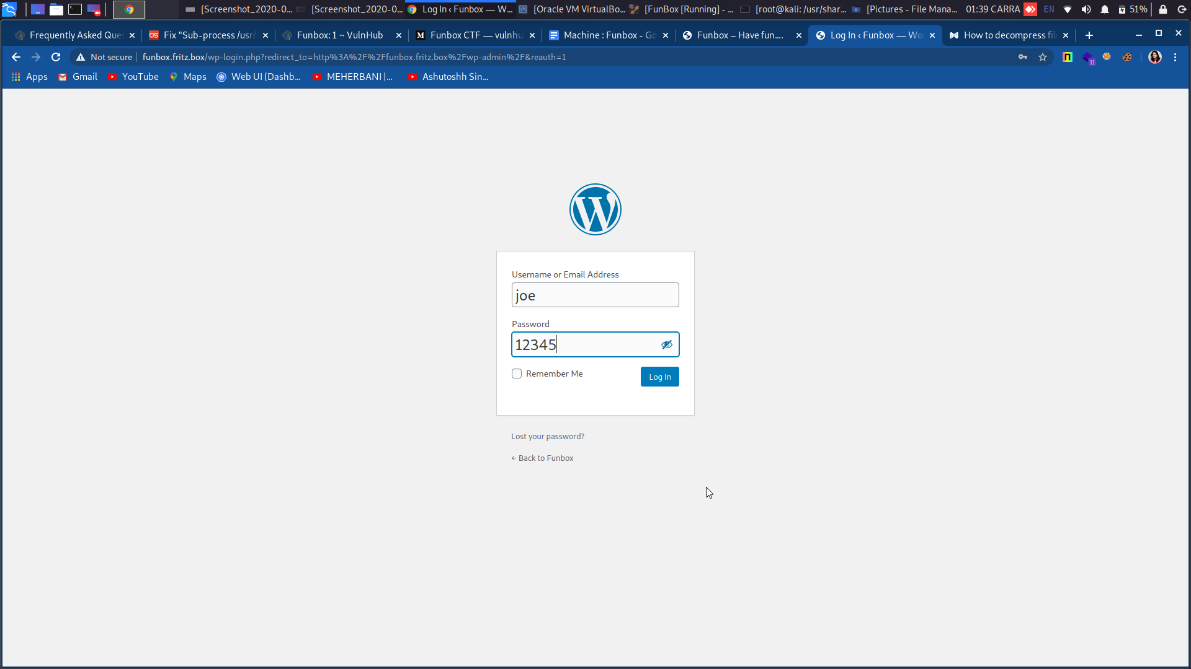

**So, here we can access it but the user doesn't have much permissions:**

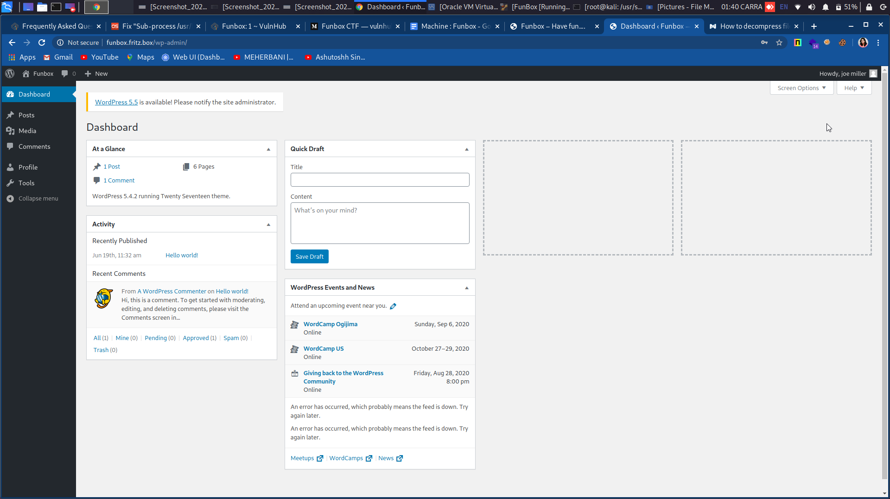

**Based on the results from nmap, we’ll try the other entry points, starting by the FTP. ftp command is useful when we work on a server without GUI and you want to transfer files over FTP to or from a remote server. When downloading files with the ftp command, the files will be downloaded to the directory from which you typed the ftp command.**

**Based on the results from nmap, we’ll try the other entry points, starting by the FTP. ftp command is useful when we work on a server without GUI and you want to transfer files over FTP to or from a remote server. When downloading files with the ftp command, the files will be downloaded to the directory from which you typed the ftp command.Based on the results from nmap, we’ll try the other entry points, starting by the FTP. ftp command is useful when we work on a server without GUI and you want to transfer files over FTP to or from a remote server. When downloading files with the ftp command, the files will be downloaded to the directory from which you typed the ftp command.**

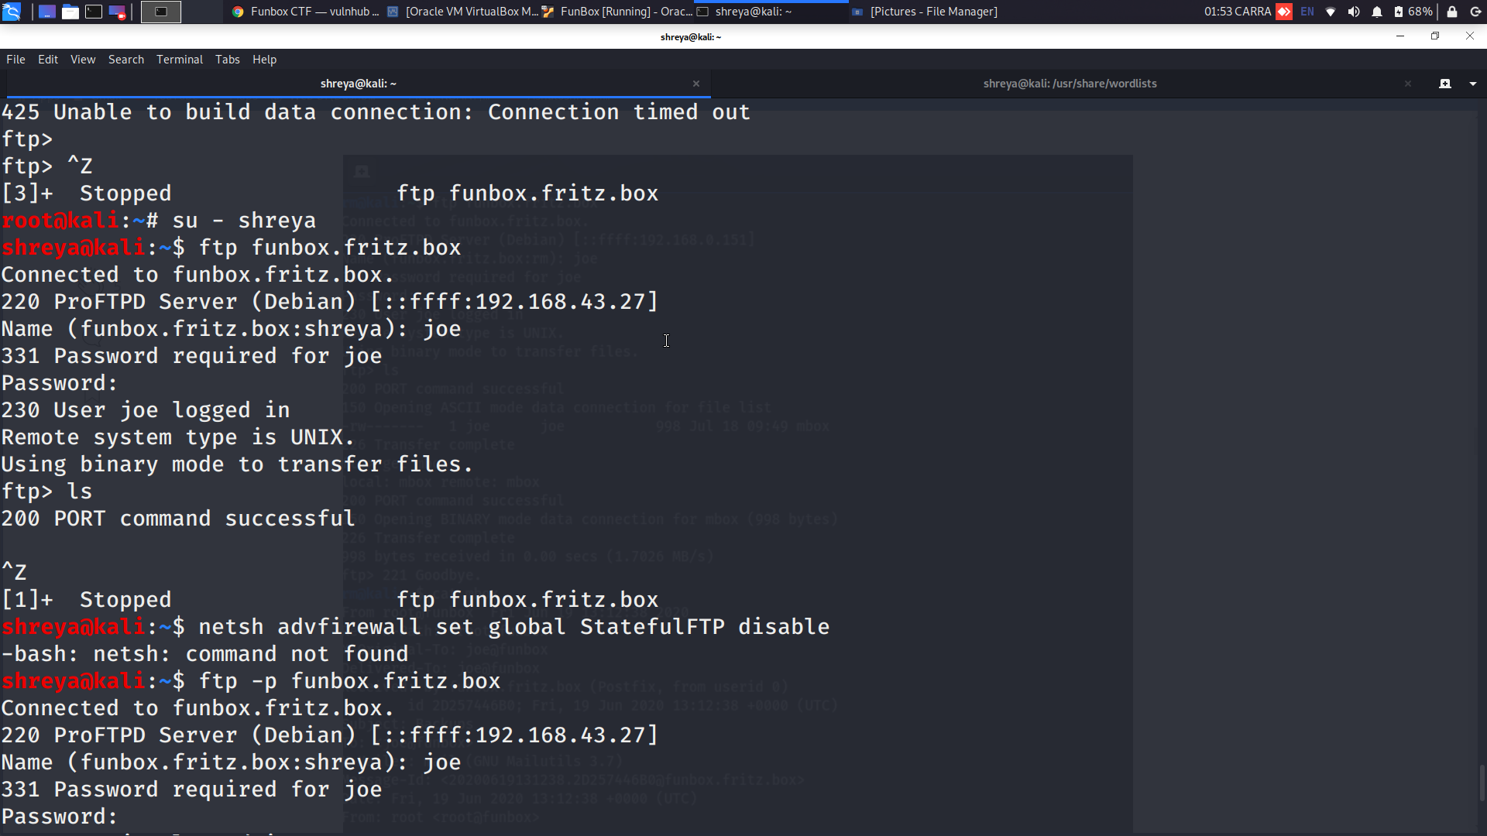

**We get an error here. Let’s try out the passive mode**

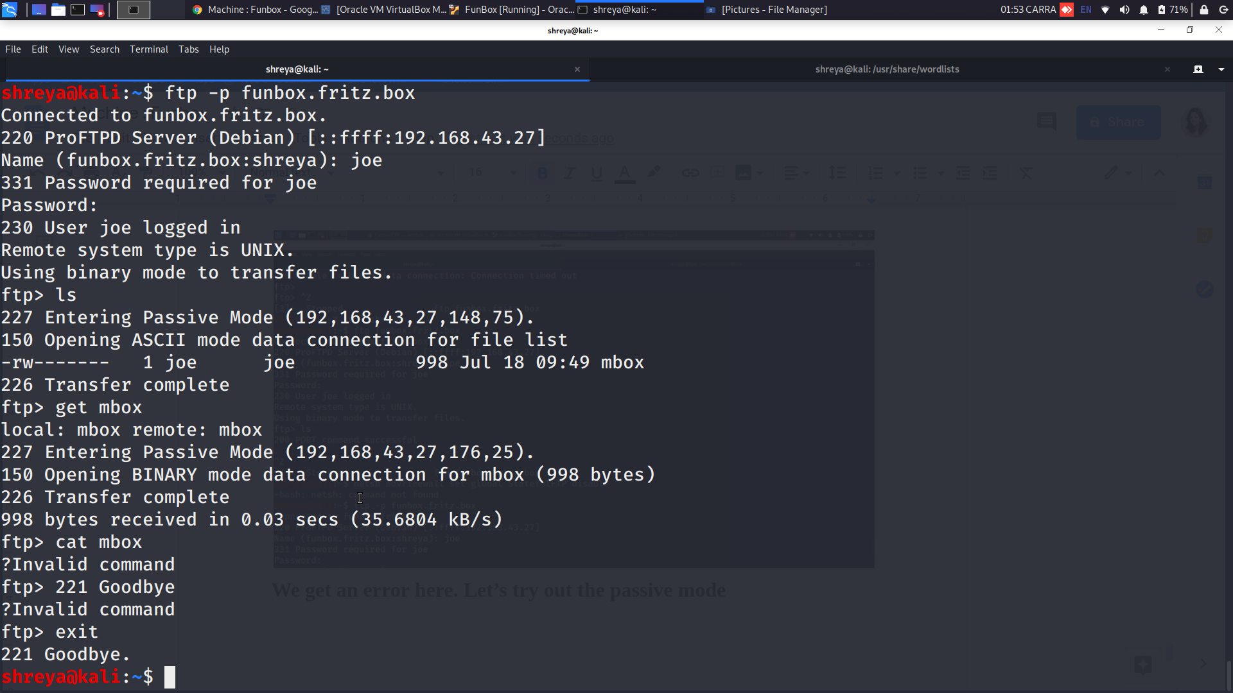

**Yup, it's running !!**

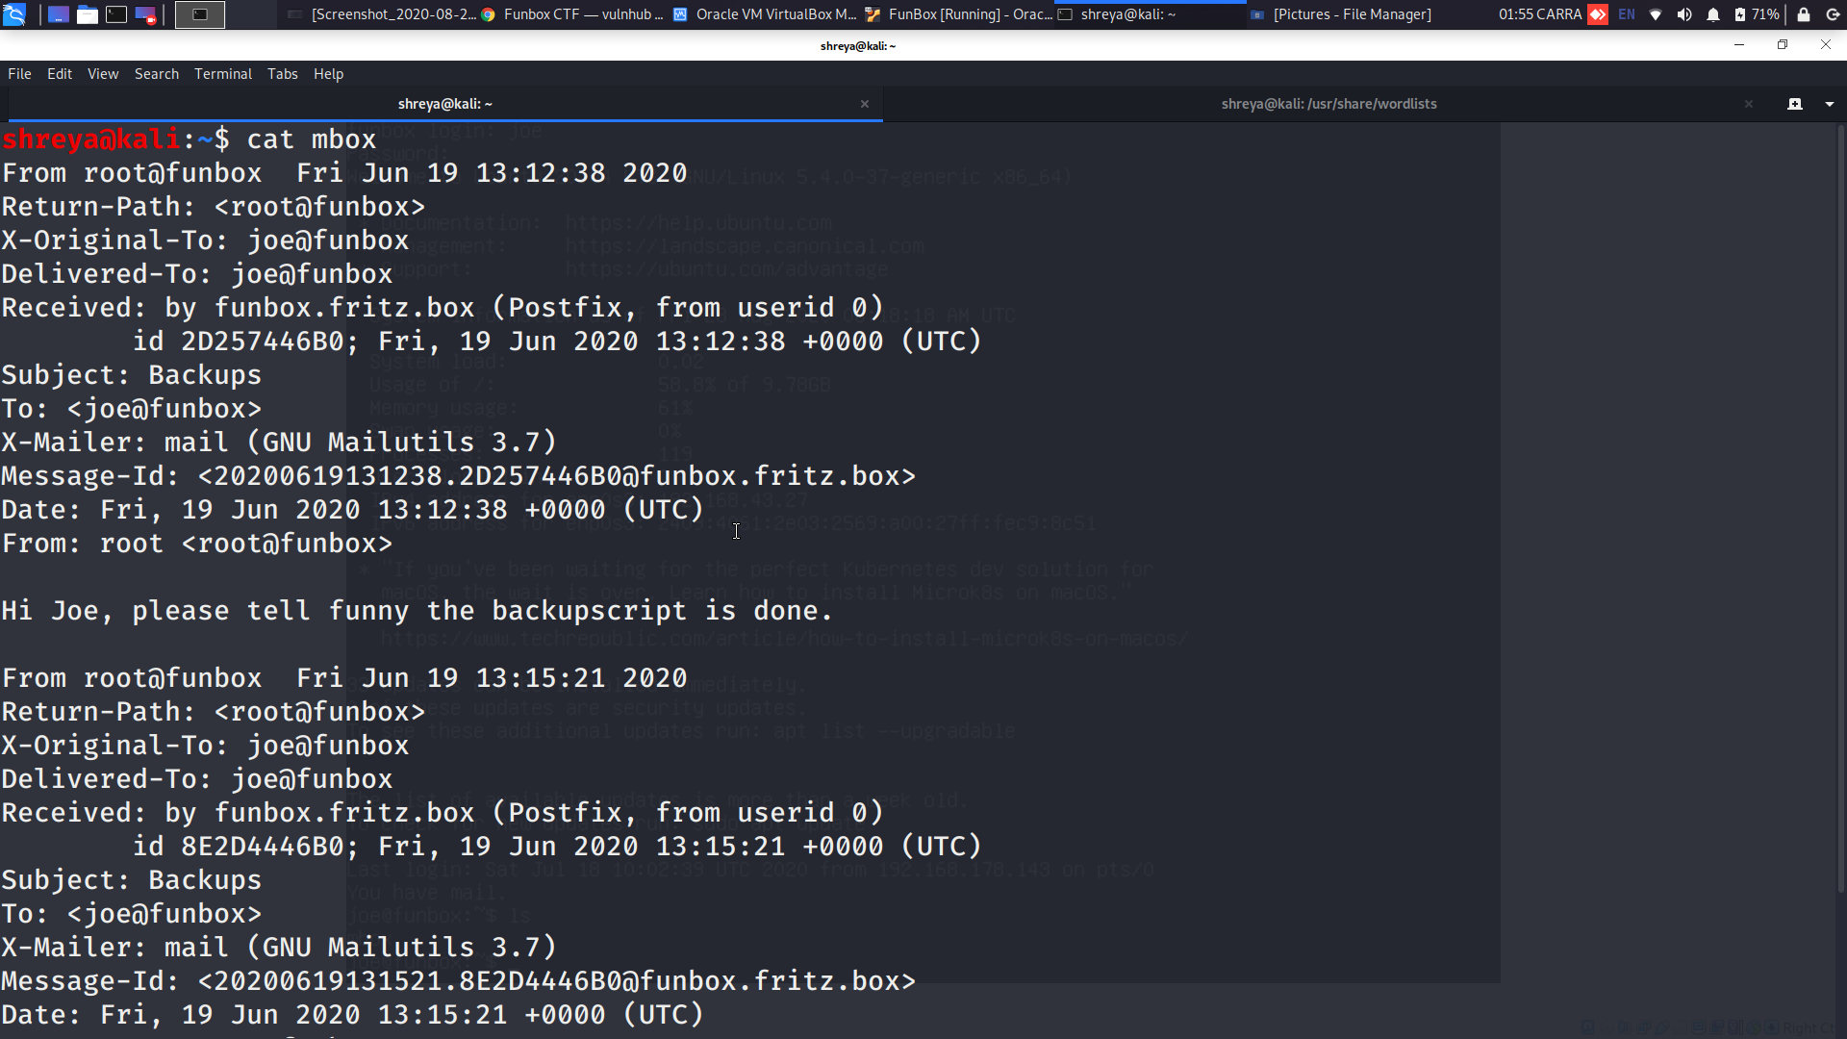

**Credentials are valid on FTP and we can extract some emails.**

**Let’s see if the credentials matches SSH:**

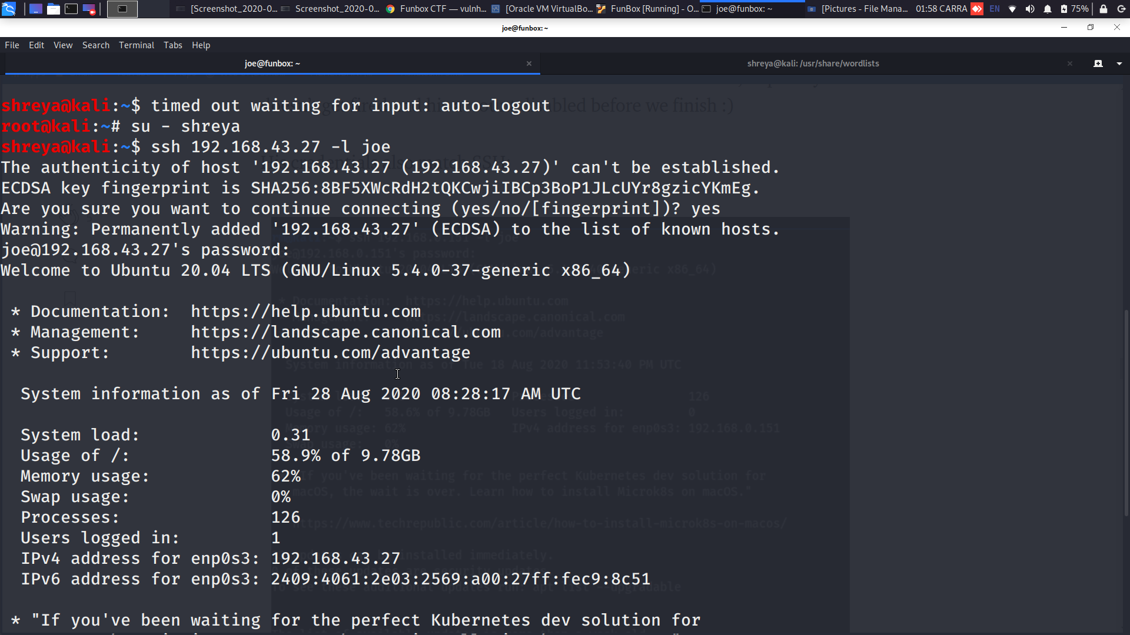

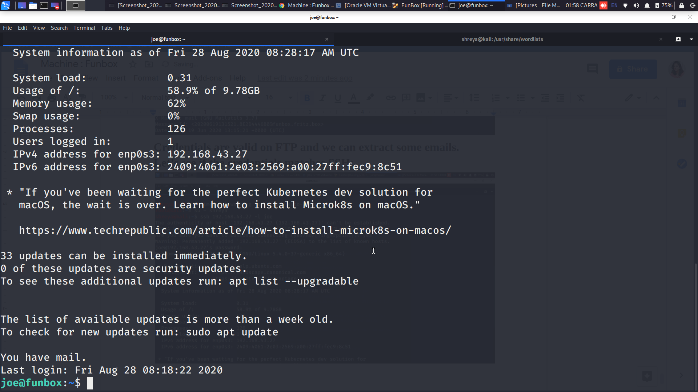

**Time for privilege escalation! Let’s see his sudoer permissions:**

**Found an HTML script in the funny directory and the modified date matches the VM time. Maybe a cron job was running to generate the file. Let's find it out.**

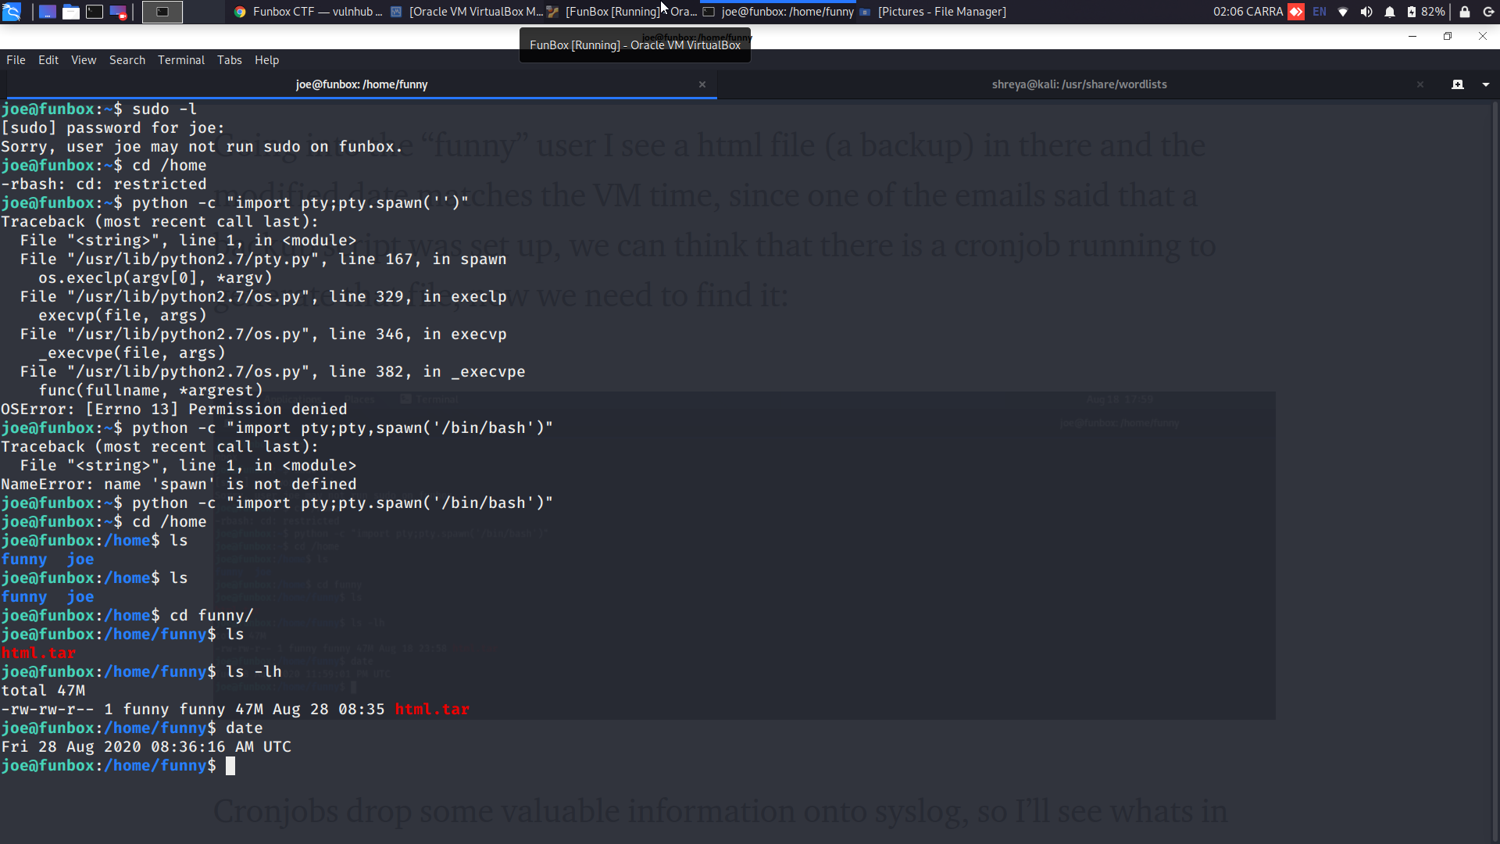

**Spawn a process, and connect its controlling terminal with the current process’s standard io.**

**Cronjobs drop some valuable information onto syslog, so I’ll see what's in there:**

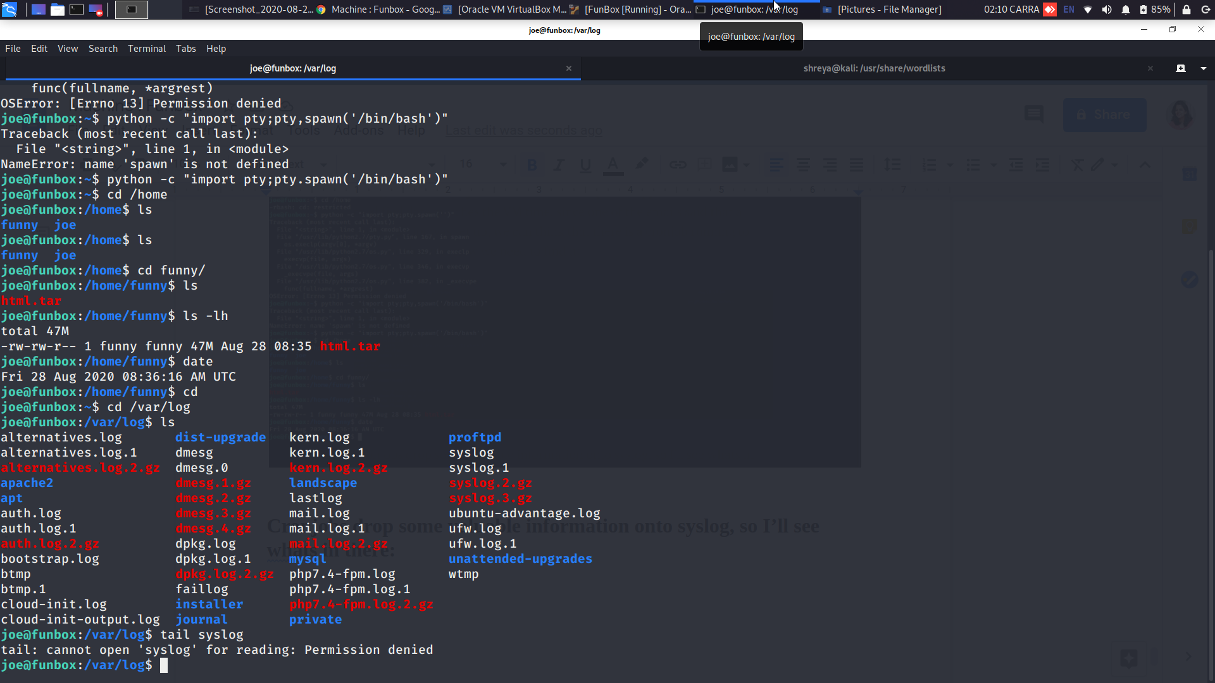

**Since that didn’t work, I‘ll go back to the home folder, ll will reveal the dot files with an executable .backup.sh file in it, upon inspection it matches the .tar file we’re seeing and the owner is “funny”, we might be able to get more stuff with this user:**

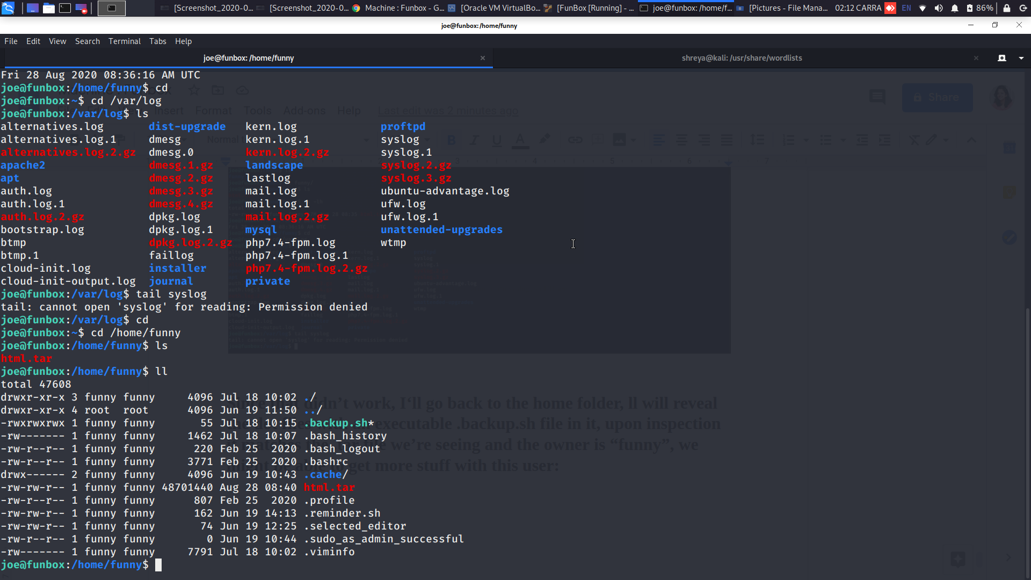

**So now I am going to edit the backup script, set it to go to funny’s home and add my ssh key to his authorized_keys folder:**

